Lab5

Dawid Skraba 19433692

Task2:

Task3:

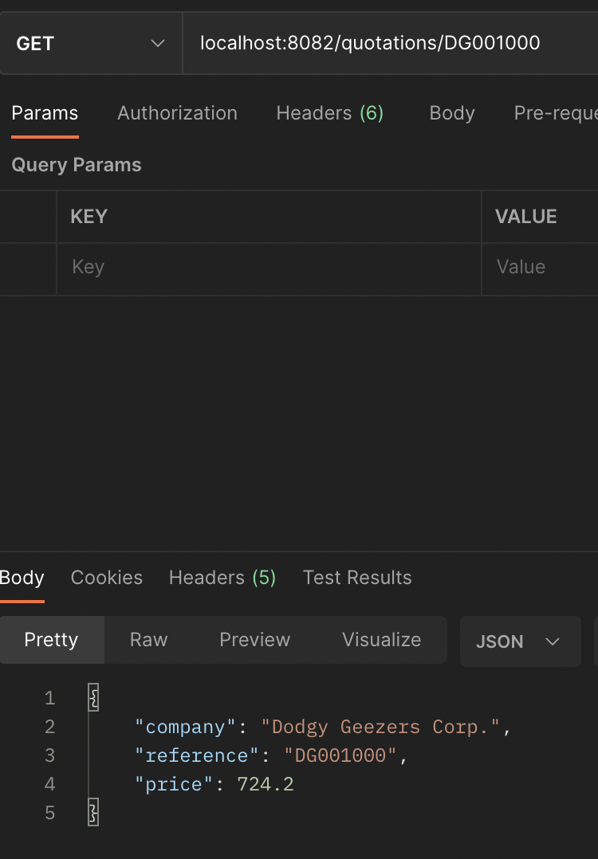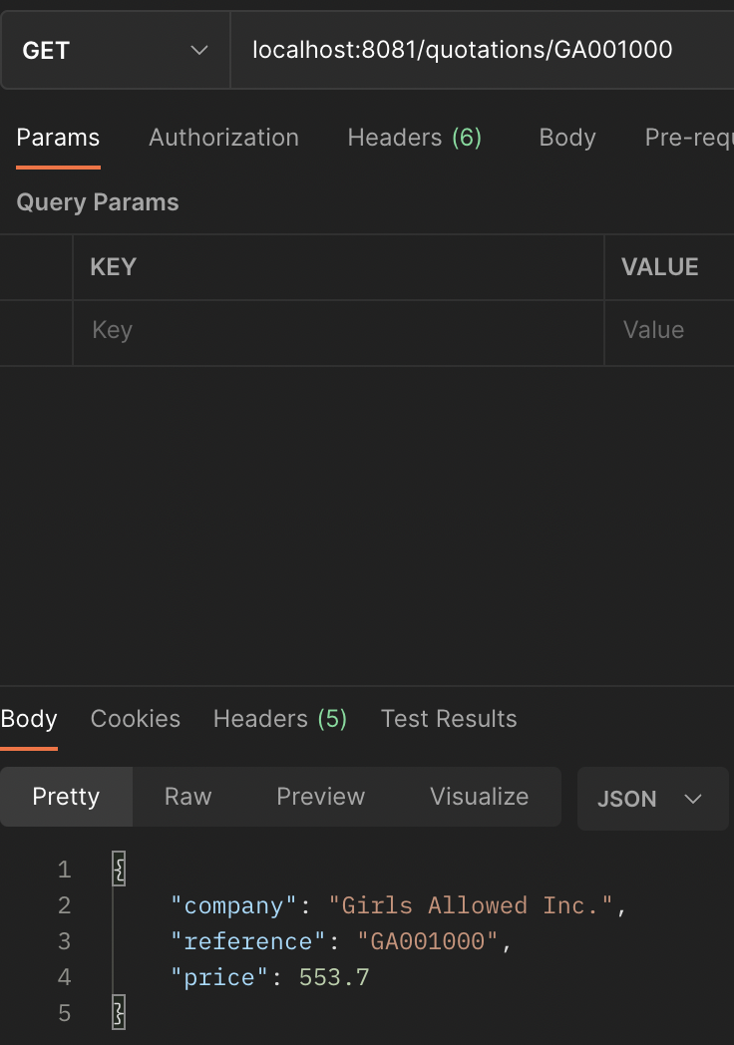

Task4:

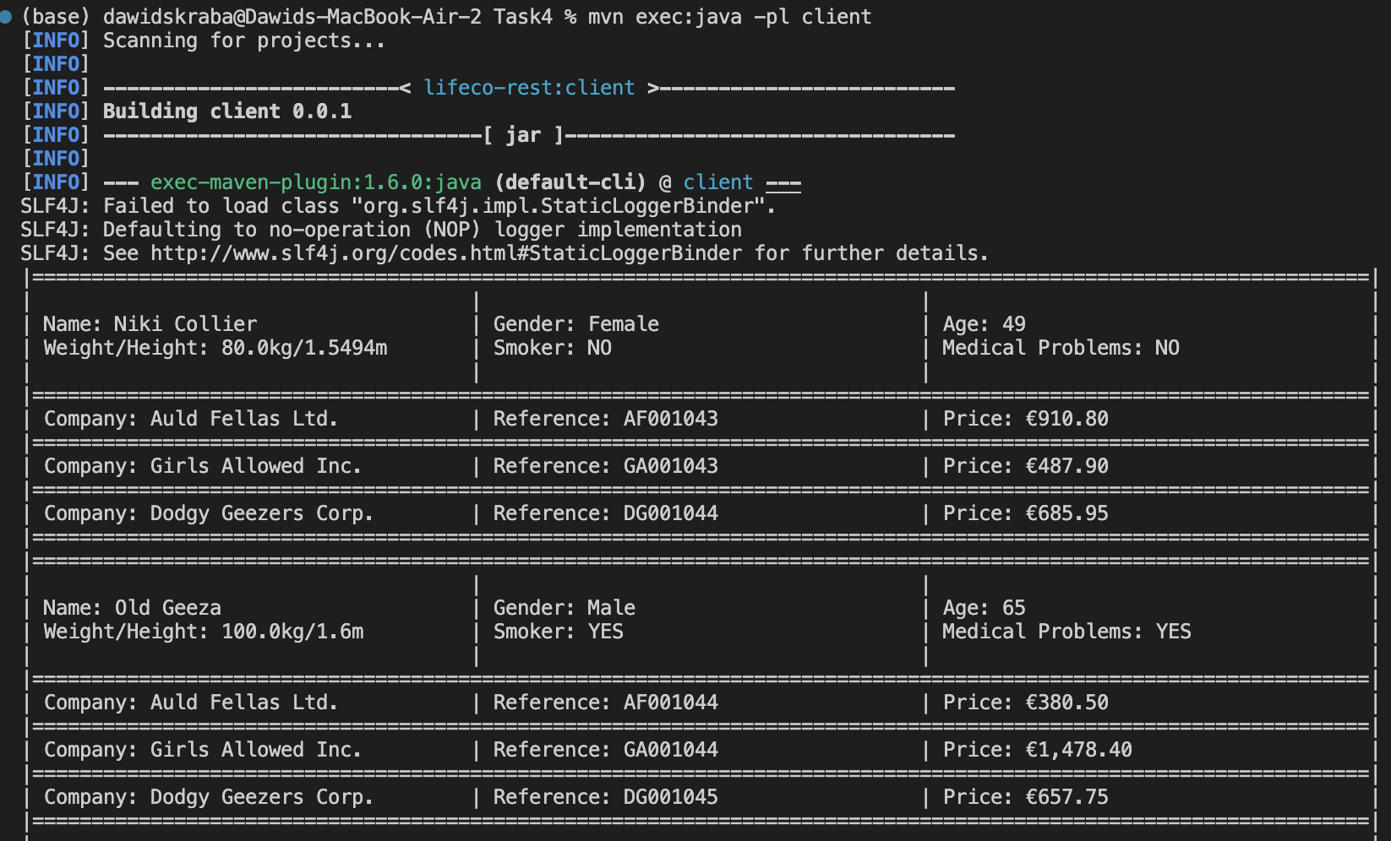

Task5:

Completed all tasks + the task to make a service endpoint